Design: CFLEX2.0 SAGUI Changes for Pending Trade

Overview

1.1 Requirement:
- A new “Pending Trade” window will be available for the Helpdesk. This window will have the following type of Pending Trade.
  - Fixed Strategy trade.
  - Percentage Simple Order Trade
  - Percentage Strategy Trade
- The following information needs to be defined/approved for the different type of Pending Trade:-
  - Fixed Strategy trade—Leg Prices
  - Percentage Simple Order Trade- Underlying Strike Price
  - Percentage Strategy Trade- Underlying Strike Price and Leg Prices

1.2 Scope:

Implementation

2.1 IDL Changes

2.1.1 CMI IDL Modification
- None

Other IDL Modification:
- None

3. Global Server

3.1 Classes & Interfaces
- None

3.2 Scripts
- None

3.3 Database Changes
- None

3.4 SetContext
- None

3.5 XML/DTD
- None

4.Client

SACAS Changes
- TradeMaintenanceServiceImpl.java
Added new methods to Add leg price ,upadate the strike price and pending trade which are :

public void acceptLegPricesForTrade(String tradingSessionName, int productKey, CboeIdStruct tradeId, String userId, LegTradePriceStruct[] legPrices) throws SystemException, CommunicationException, AuthorizationException, DataValidationException, NotAcceptedException, TransactionFailedException, NotFoundException

public boolean updatePendingTradeStatus(String sessionName, int classKey, CboeIdStruct tradeId, String userId, short tradeStatus) throws SystemException, CommunicationException, AuthorizationException, DataValidationException, NotAcceptedException, TransactionFailedException, NotFoundException

public void setPriceForProduct(String sessionName, int productKey, PriceStruct underlyingPrice, CboeIdStruct tradeId, String userId) throws SystemException, CommunicationException, AuthorizationException, DataValidationException, NotAcceptedException, TransactionFailedException, NotFoundException

- TradeMaintenanceServiceClientRoutingProxy.java
Added three new methods to route them to respective BC’s.

- TradeMaintenanceServiceAdminClientRoutingProxy.java
Added three new methods to route them to respective BC from SACAS.

- TradeMaintenanceServiceProxy.java
Added three new methods to route them to respective BC’s.

- TradeMaintenanceServiceRoutingProxy.java
Added three new methods to route them to respective BC’s.
GUI

SAGUI Changes

Changes for Creating Pending trade window
To show a new pop-up window for pending trades, we need to create below classes:

- PendingTradeLaunchAction.java
Create a launch action for pending trade window.

- PendingTradeLaunchActionType.java
Create a launch action type for pending trade.

- PendingTradeFrame.java
Create a configurable top frame for pending trade

- PendingTradeFilterPanel.java
Create a panel to add all the components by which a help desk user can filter the pending trades like Order Id, product class, trade status, product series and by time.
In product class

- PendingTradeTablePanel.java
Create a panel to add the pending trade information into a table format. A Help desk user can submit underlying price/approve price based on trade status.

- PendingTradeTableRow.java
Create a table row which has all the columns required in pending trade table.

- PendingTradeTableModel.java
Create a table model which would be having all the pending trade data. We would only add package level fill reports in case of a strategy product.

- PendingTradeTableConfig.java
Create a table model which would be having all the pending trade data.

- DefineUnderlyingPriceDialog.java
Create a dialog for defining underlying strike price for both simple and strategy product.

- DefineLegPriceDialog.java
Create a dialog for defining leg price for a strategy product. If Help desk wants to edit the leg prices entered by a trader, same dialog would be used.

- ApproveLegPriceDialog.java
Create a dialog to approve the leg prices defined by a trader. Help desk can also change the status to “On Hold” from the same screen.
We would use the updatePendingTradeStatus of TradeMaintenanceService to update the trade status.

- FlexTradeServiceAPI.java
Create a new interface which has set of methods to load all pending trades, to define leg prices and underlying prices, to approve leg prices and approve or put it on hold.

- SystemAdminAPI.java
It will extend FlexTradeServiceAPI to have all the methods for updating the trade status.
- SystemAdminAPIImpl.java
We need to define implementation for all the methods to load pending trades, define leg prices and underlying prices, to approve leg prices and approve or put it on hold.

Sequence Diagram:

Pending Trade Query:

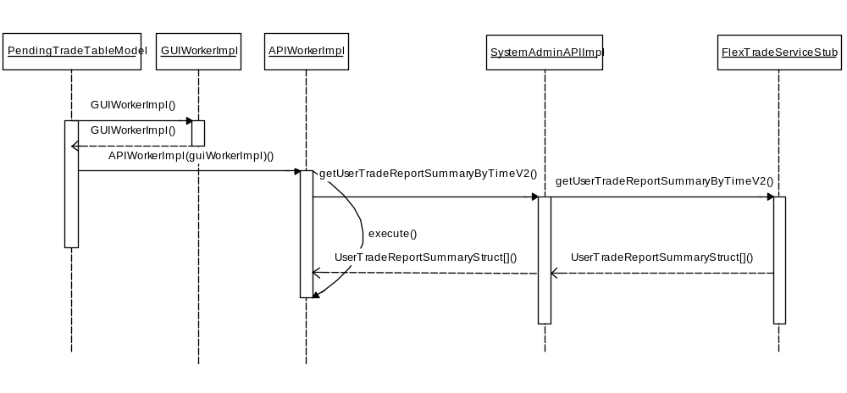

Update Trade Status (Change trade status to On Hold):

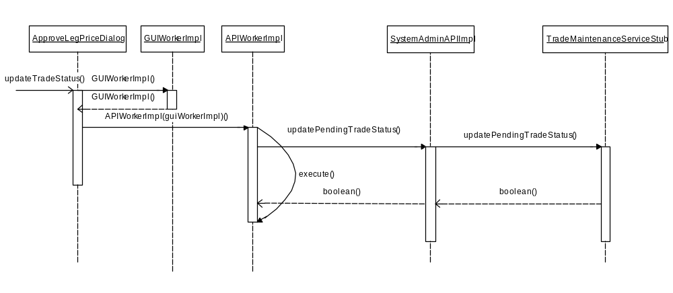

Define Underlying prices:

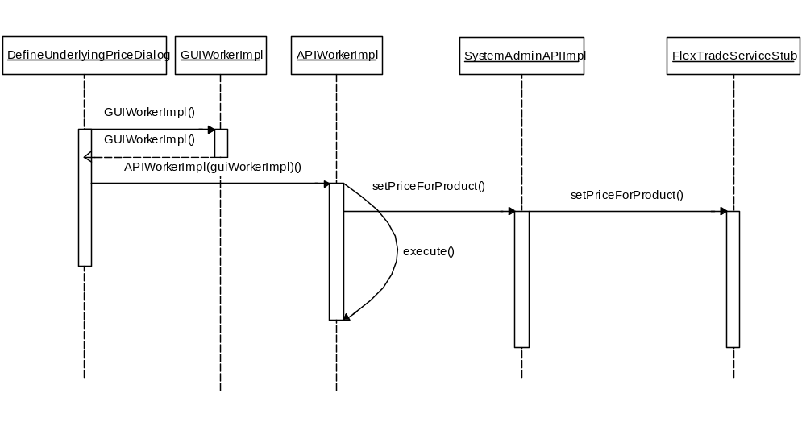

Define Leg prices for Strategy:

